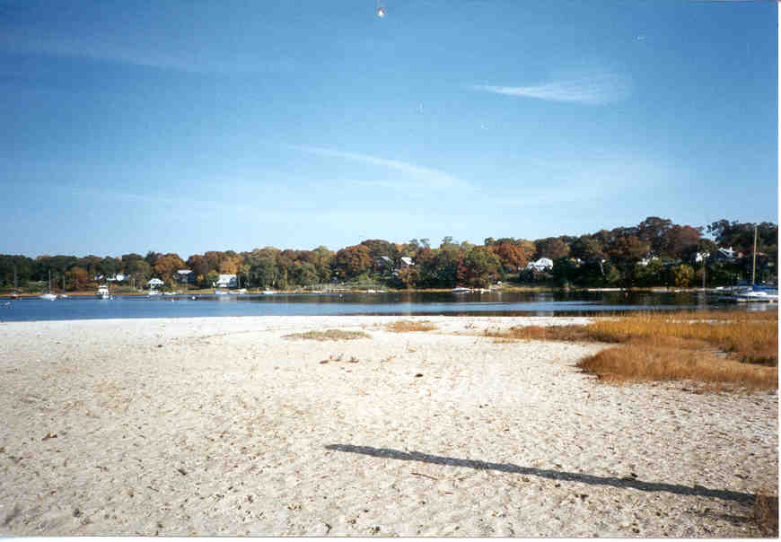

Cedar Tree Point Association - Founded 1924

Cedar Tree Point Association Annual Meeting Agenda 11-21-03

1. Meeting called to order – Dave Pickering - president
- Welcome to all & introduction of CTPA officers
- Welcome and Introduction of new members
- Establish a quorum (eight members constitute a quorum)

- Reading of the minutes of the last Semi-Annual Meeting.
- Read by the Secretary –
- Minutes to be amended if necessary and then voted to be accepted.

- Report of the Treasurer – Mike Hoglund
- Current Balance of the Checking Account
- Current Balance of the Market Account

- Report of the Committees
- Report of the Interior Committee:
- Cemetery Report
- Report of the Waterfront Committee:
- New 12’ Picnic Table!
- Fish Kill, Closing of Beach, Fish Kill & Loss of Shell fishing
- Report of the Social Committee:
- May 31st Beach Clean Up and Community Breakfast
- July 13th Campfire and Somores on the “Point”
- July – A New 12’ Picnic Table on the Beach
- August 2nd Annual Steak Fry & Campfire on the Beach
- September 20th – 1st Annual Lobster Clam Bake & Campfire on the Beach
- Discussion of any old business

- Discussion of any new business
- Developing slate for 2003-2004 Cedar Tree Point Board Members
- Vote on 2003-2004 Board Members
- Dave Pickering – The development of the “Cedar Tree Point” Web Page
http://hometown.aol.com/ctpassociation/myhomepage/business.html
- Jack Early - Update on the “Defenders of Greenwich Bay”
- Carol Fritz will give an Update of the “Greenwich Bay Special Area Management Plan (SAMP)”

7. Adjourn Meeting

